Technical test : Create two rest service

The first service /api/addUser : allows to register a user.

The second service /api/user : displays the details of a registered user.

The third service /api/users/{userId} : allows to retrieve a user by id

1. Entity user :

* The mandatory fields are :
  + Id
  + firstName
  + lastName
  + birthday
  + dateRegistration.

- The optional fields is :

* + phoneNumber.

1. The optional parameter phoneNumber has a default value in case is not set, this value is: 0123456789.
2. The userId id a path variable to get a specific user.
3. the javadoc is available in the folder doc
4. I did three unit tests to test each functionality
5. I did two annotation (@Adult and @France) to test both features (only adults > 18 years)  and living in France)

Bonuses:

1. for the two service I use a mangoDb
2. I use AOP
3. You can get documentation from the url : <http://localhost:7070/swagger-ui.html#/user-controller>
4. UML :

Class User:

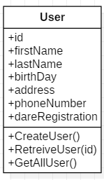

Use case Diagram for manage user:

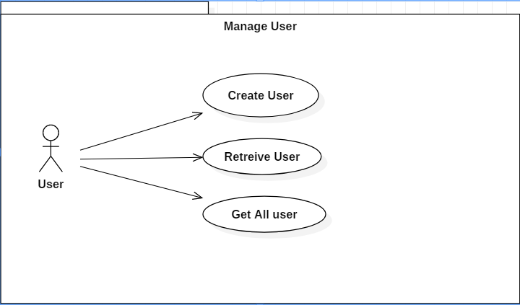

sequence diagram for create user:

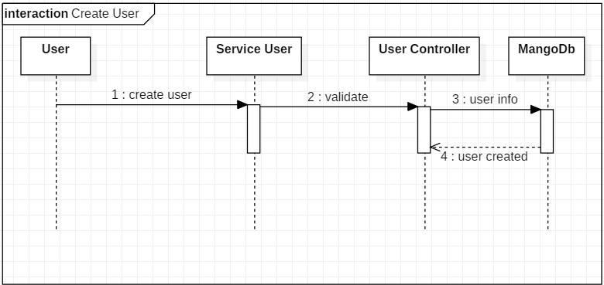

1. Schemas to explain the architecture

